Event Report: World Humanitarian Day 2025

Organized by Zoram Entu Pawl (ZEP), Aizawl, Mizoram
Date: 19th August 2025
Venue: I&PR Auditorium, Treasury Square, Aizawl

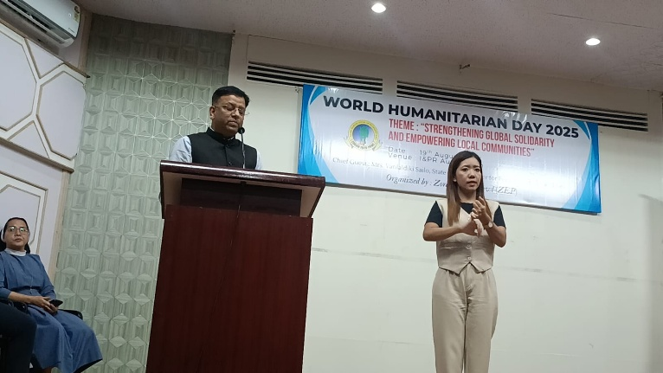
The first-ever World Humanitarian Day 2025 in Mizoram, organized by Zoram Entu Pawl (ZEP) at Aizawl on 19th August 2025. The event was hosted by Sr. Helen, Chief Program Officer (ZEP). The occasion brought together government representatives, humanitarian agencies, and civil society.
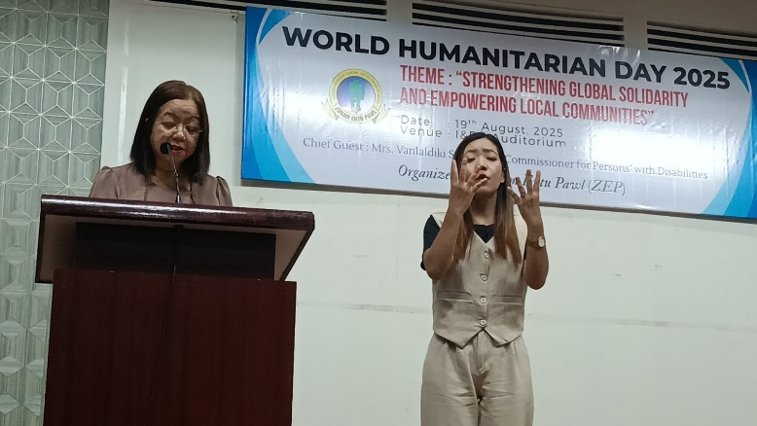
Bishop Stephen, President of Zoram Entu Pawl, opened the days gathering with a message of solidarity. He stressed on the Mizoram spirit of tlawmngaihna—(selflessness and service) that echoes global humanitarian values.
Mr Dhirjai Kumar, CAM, HI

Ms. Vanlaldiki Sailo, Disability Commissioner, Government of Mizoram, graced the event as Chief Guest accompanied by Sign Language Lnterpreter. She highlighted that the biggest challenge faced by Persons with Disabilities (PwDs) is not inadequate infrastructure but attitudinal barriers in society, calling for respect, dignity, and empathy rather than sympathy. She also welcomes any suggestion and support from humanitarian agencies to improve the service delivery towards the disabled persons.
Disability Commissioner, Ms Vanlaldiki

Mr. Dhiraj Kumar, CAM-HI, delivered the Special Message of the Day. He underscored the importance of collective action to ensure that humanitarian efforts reach the most vulnerable, expressed solidarity with humanitarian workers across the globe, and lauded the Mizo people for their commitment and contribution to humanitarian causes

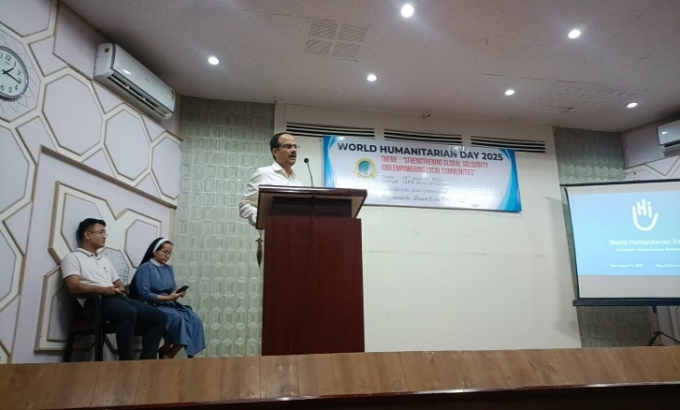
Humanitarian agencies including Central Young Mizo Association, Adventist Development and Relief Agency (ADRA), MDPO/OPD – Mizoram Disabled People’s Organization / Organization of Persons with Disabilities, Mizo Hmeichhe Insuihkhawm Pawl (MHIP, the largest Mizo Women’s Federation in Mizoram), SELCO Foundation, SHALOM – Society for HIV/AIDS Lifeline Operations in Mizoram (commonly known as SHALOM), Jesuit Refugee Service (JRS), Migration and Asylum Project (MAP) and Spastic Society of Mizoram shared their experiences highlighting the value of collaboration and resilience Although a few confirmed participant agencies, including MSF and CRS, were unable to attend due to prior commitments, they graciously conveyed their best wishes and reaffirmed their strong commitment to actively engage in forthcoming initiatives and contribute meaningfully towards advancing inclusiveness.

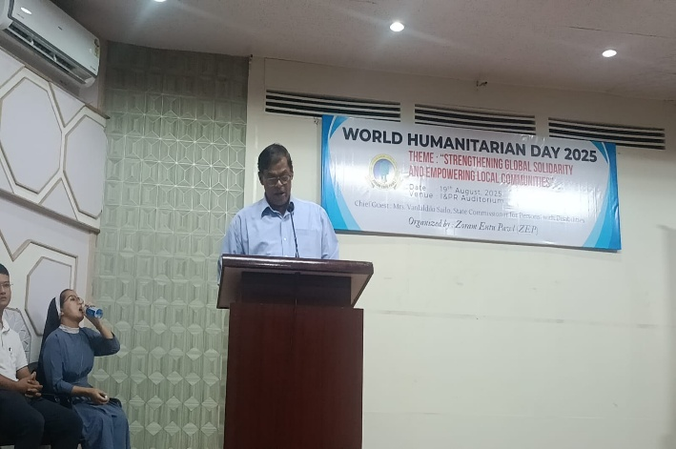
Mr. Shiwendra Kumar facilitated a brief session on International Humanitarian Assistance (IHA), addressing the legal framework, barrier and challenges faced by the PWDs, and the appropriate etiquette and behavior when engaging with disability issues. The core message was on promoting sensitivity, inclusiveness, and accountability in humanitarian action.
Mr Shiwenra, HI

The program concluded with a Vote of Thanks by Fr. Michael Soosai, Director of ZEP. He affirmed ZEP commitment and pledged to strengthen partnerships, amplify marginalized voices, and build resilience.
Fr Michael Soosia, Director ZEP

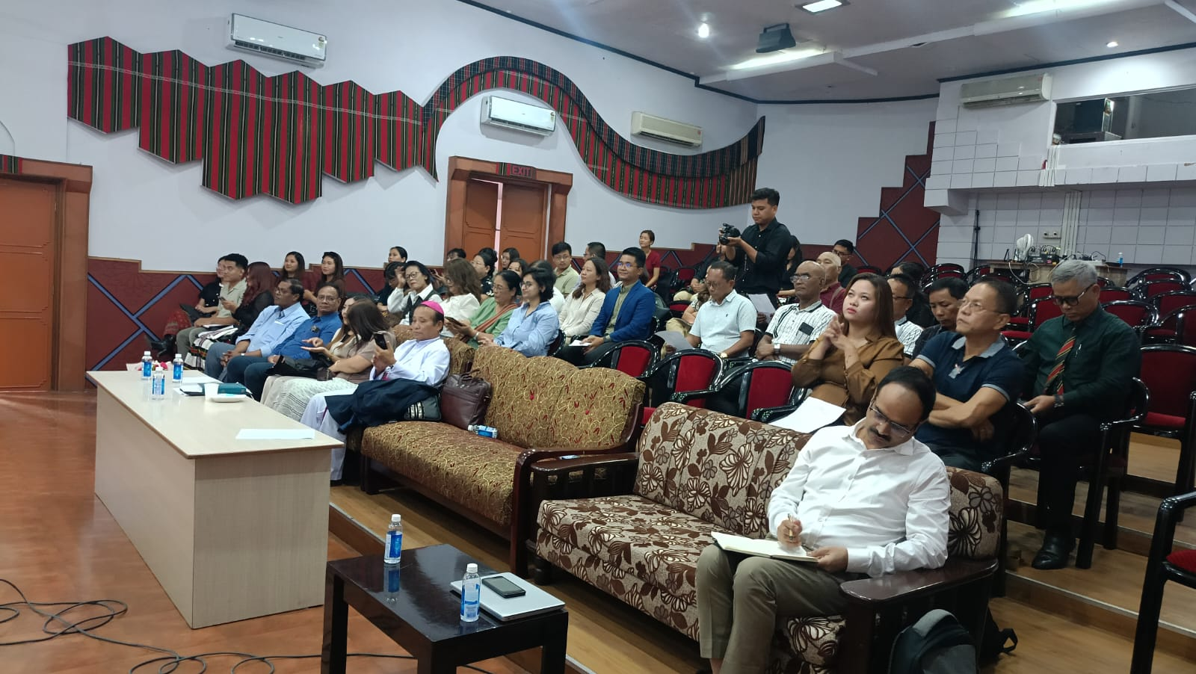
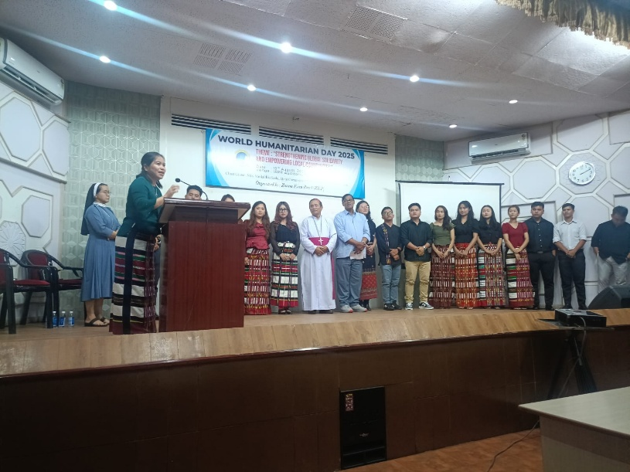
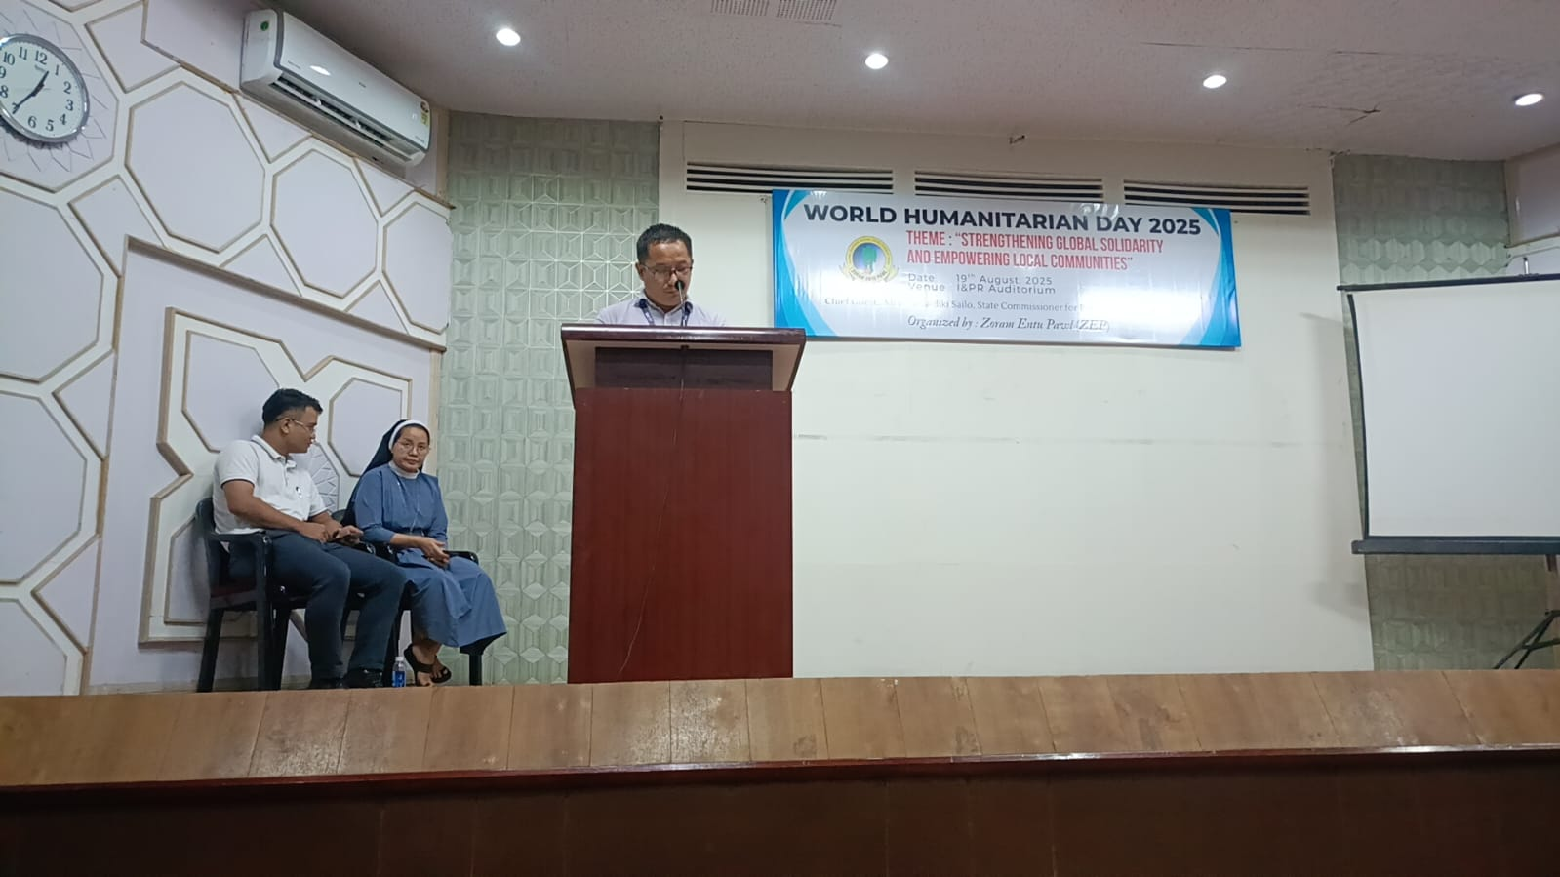
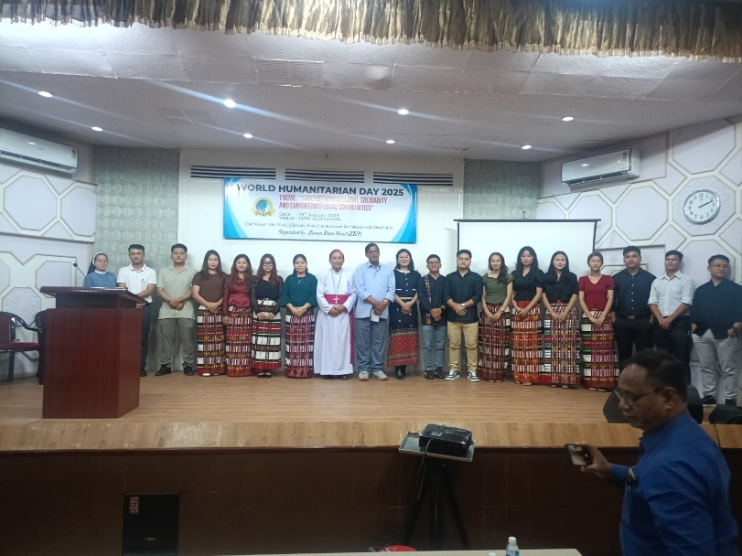
Photos

